Document Number: 000xx Document Issue: 1.5
Date Issued: February 9th2002 Document Status:
                - Filing Path:
                - Document Title: Project Quality Plan
                - Author: Joe Nickolls
                - Keywords: Simpsons, goal, user, rewards, gameplay, art, quality

Revision History

Issue | Date | Person | Reason - include problem #, ECN #, etc.
1.0 | February 9th2002 | Joe Nickolls | First pass at this document
1.1 | February 13, 2002 | Joe Nickolls | Revisions Based on Laurent’s feedback
1.2 | February 14, 2002 | Joe Nickolls | More revisions. Checklist added.
1.3 | February 18, 2002 | Joe Nickolls | More revisions and the inclusion of Xbox – Wreckless as a competitive product.
1.4 | February 27, 2002 | Joe Nickolls | Added Checklist elements
1.5 | Feb 28th | Joe Nickolls | More revisions

Table of Contents

1 Purpose of the Quality Plan 3
1.1 Overview 3
1.2 Market Analysis 3
1.3 AAA Definition 10
2 Product Quality Goals 11
2.1 Fun to play – Funny to play. 11
2.2 The Eye / Ear Candy. 12
2.3 Checklist for IP – ingame. 13
2.4 Unlockables and Rewards. 13
3 Product Quality Checklist 14

Purpose of the Quality Plan

Overview
The goal of this document is to provide a “measurable” standard to which our game will be held. Team goals, benchmark, and comparisons will be used to evaluate the level of quality, on an ongoing basis throughout the project. These exercises will also drive the quality review meetings.

Market Analysis
An analysis of various driving games on the market. We won’t focus on the racing genres such as Gran Turismo or Project Gotham racing, but rather the hybrid driving games like Grand Theft Auto, Driver, and SpyHunter

Grand Theft Auto
Units sold PS2 – 1,965,832 since launch – Oct 2001.
Grand Theft Auto is the first in the genre of driving games to employ an engine for both driving, and controllable characters that can interact with a huge world. This is the 3rd in a series of GTA games, and this third instalment takes the game from a top down, 2d game, to a fully immersive 3d environment. The gameplay was more groundbreaking than addictive. The appeal is - you can go anywhere, and do anything. This is already the #4 game out of the top 250 games sold from January 2000 – Present, and this after only 3 months or release.
Although this is a driving game in “image” only, the most popular and engaging element is the ability to do things you’ve never been able to do before. Carjacking, Heists, Murder, Robbery, Prostitution, etc. GTA3’s focus is the sleaze of the world, and the public ate it up.
- The game garnered a lot of publicity due to its mature theme, and shock factor on the gameplay elements
- The driving was realistic and employed vehicular damage
- The game used great lighting and shading for dramatic effect.
- The in game audio was customizable via the radio – (very cool)
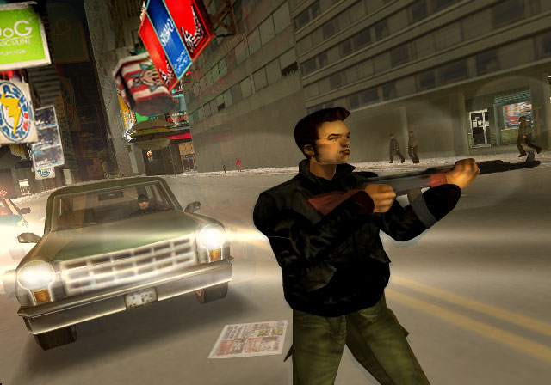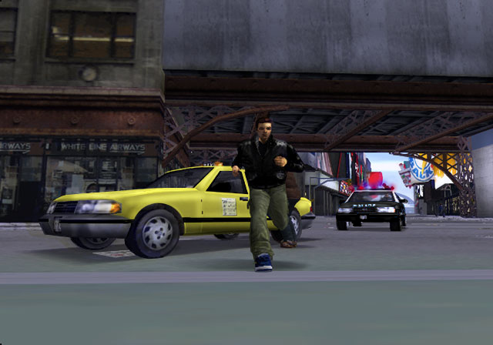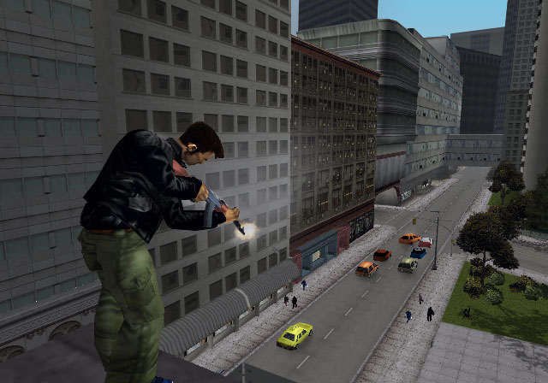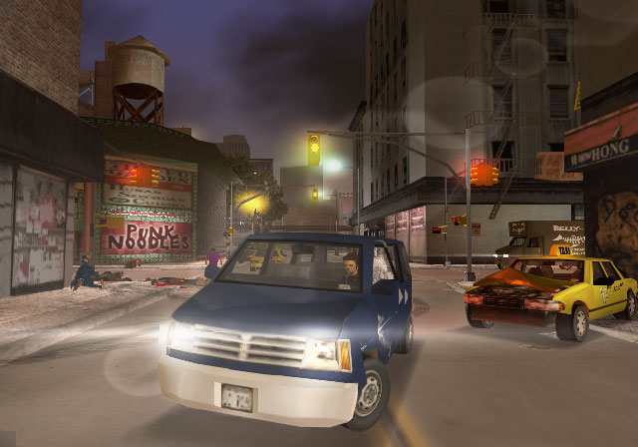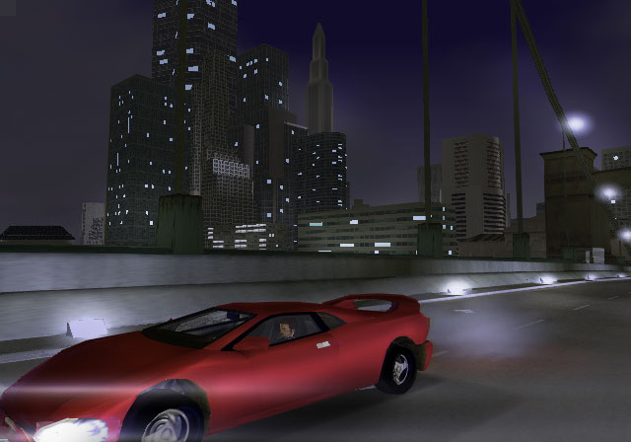

Driver 2
PSX 1,565,694 Units – since Launch Nov 2000.
Driver 2 is the follow up to the very successful – Driver for PSX. (The original title is the #2 selling game on the top 250 chart since January 2000 with over 2.3 million units sold) This was the beginning of the “out of the car” element in a driving game. Although the action was limited, it raised the bar on story-based games that are centred around vehicles. This is a gritty, dirty-feeling game, which is based on a long storyline, told through lengthy NIS sequence.
- A great driving engine, interesting vehicles.
- Vehicular damage and physics
- An engaging storyline
- The first get out of the car element game
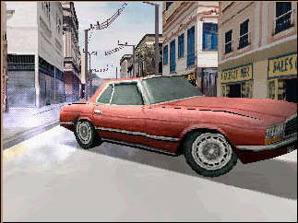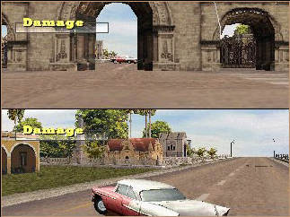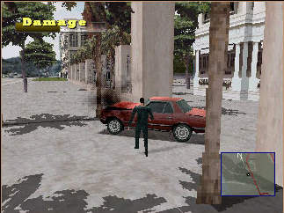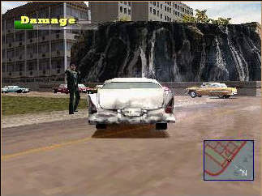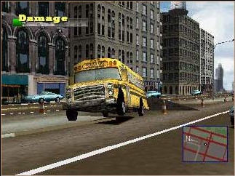

Smugglers Run / Smugglers Run 2
SR - 1PS2 – 263,000 - Oct 2000 / Oct 2001 SR 2 – PS2 – 87,000
The Smugglers Run franchise is use for comparison due to its mission based driving system. Not a big seller, but a well reviewed game – 37 separate reviews bring this game in @ 80%.
The sequel attempts to link the missions together with a plot in the form of full-motion video cut scenes that occur every couple of missions. It’s “stay in the car” missions from the start – the key element here is the immense size of the worlds. There’s perhaps a lower level of detail on the cars themselves, but the driving is top notch, and there’s plenty of room to get your speed up for jumps and stunts. The missions are still simple, and the AI on the other vehicles isn’t as much of “pack-AI” as it was in the original game.
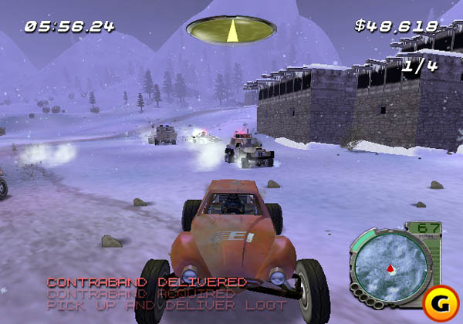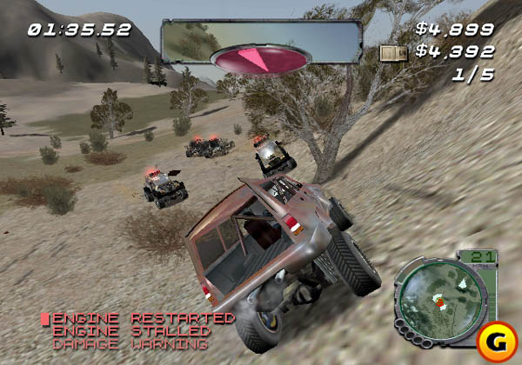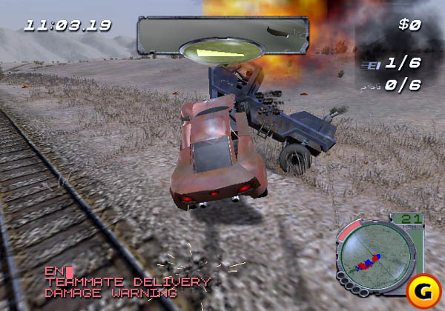

Spy Hunter
PS2 – 320,000 September / 01
This game is included, as it’s a mission-based game that takes place in a James Bond-ish environment. The missions range from simple to insane. The multiplayer aspect includes some fun tasks like mowing down chickens. The driver with the most chickens hit at the end of the course wins. You don’t get out of the car, but the car can transition from car, to boat to motorcycle. The game is part racing, part combat, and part stunt driver. Enemy AI will shoot at you and attempt to run you off the road. The storyline is one of increased complexity missions that revolve around the usual Secret Agent stuff – stop the evil foe from taking over the world by knocking out satellite receivers, etc.
Great artwork, and smooth animations are key elements here. The chicken carnage is especially due to the “fowl physics” at work. There’s also people walking around on the street, and points are taken away from your score if you hurt any bystanders.
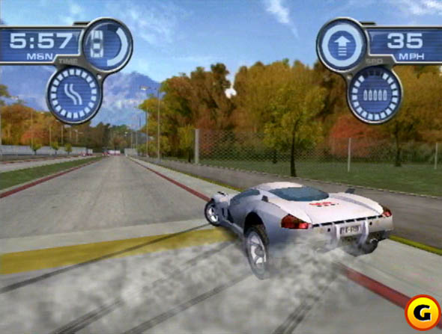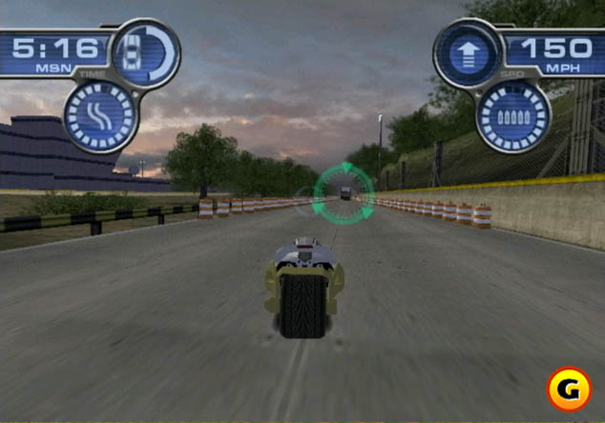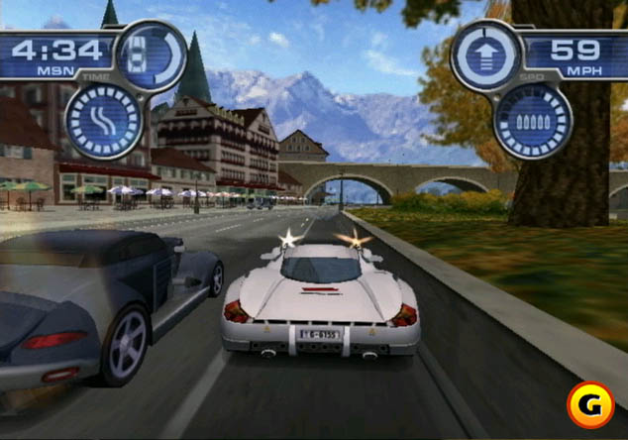

Cel Damage
Xbox – 31,988 Released Oct / 01
The reason for this game is due to the “TOON” look in a car based game. The focus of this game in its marketing and appeal is the LOOK. The game had been consistently reviewed as
- Hard to play
- Lack of depth and balance.
- The look of the game is the only selling point, as the gameplay isn’t there.
For a much-hyped Xbox launch title, the game has failed deliver in sales and reviews. The look of the game is amazing. But while the look works, the gameplay doesn’t, failing to capitalize on franchises like the Twisted Metal series. With that franchise focusing as much on look and theme, as gameplay and balance. The average review being @ 50%
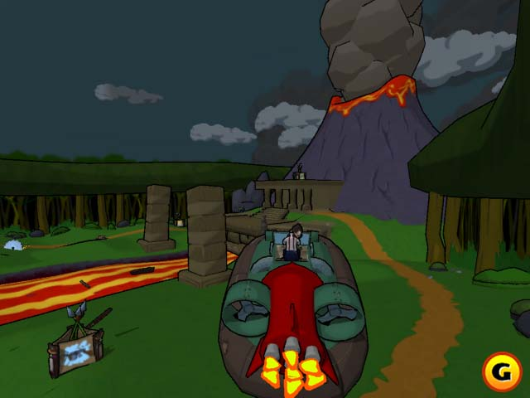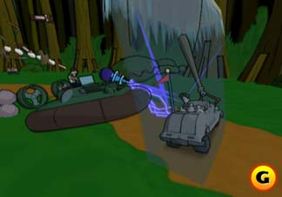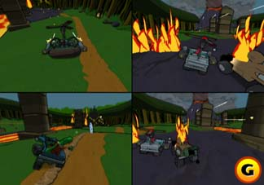

Wreckless
No sales data to date: Released Feb 2002-02-18
This game is included due its focus on In-Car adventure style play. This game has an astoundingly realistic replay engine – showing television style presentation, along with some great “filters” to add a stylized visual element to them. Another great feature vehicular damage, and although it’s not physics based, it looks great nonetheless. Another top-notch treatment is the night time levels. Plenty of neon and glitz – complete with exploding lights are a great addition.
One key feature in Wreckless is the fact that you can destroy almost everything in the game. Café’s, storefronts, guardrails, and just about every object have physics and damage applied in some way or another. This game has delivered reviews in the 60-70% range. Some criticisms centre on the game having sim-like physics with arcade style gameplay – not a perfect marriage. This game involves playing from a “small time crook” or police standpoint. Missions include running over X amount of Dim Sum stands in a crowded city (sound familiar?), or crashing into enemy vehicles to damage them to the point of destruction. This is an Xbox only title from Japan, and due to the fact that is has low exposure, and has limited appeal, will likely sell in low numbers.
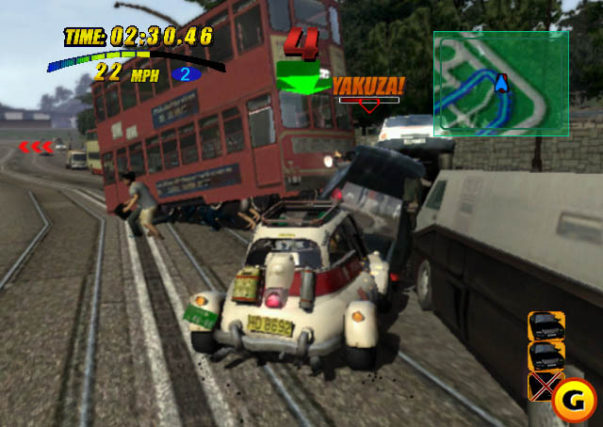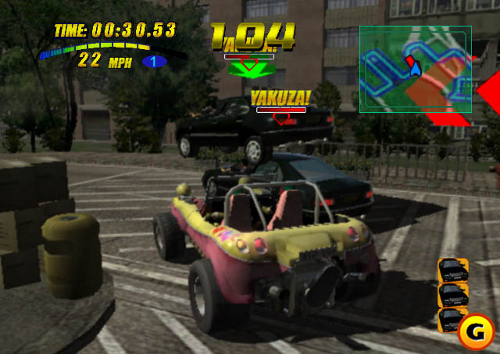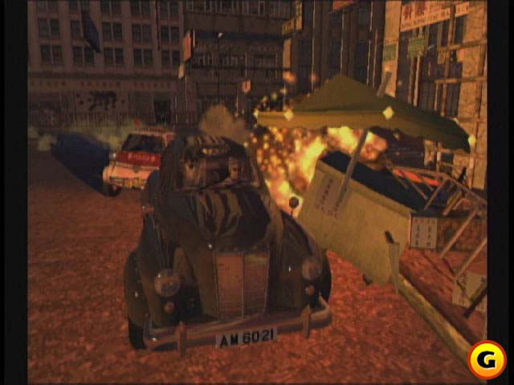
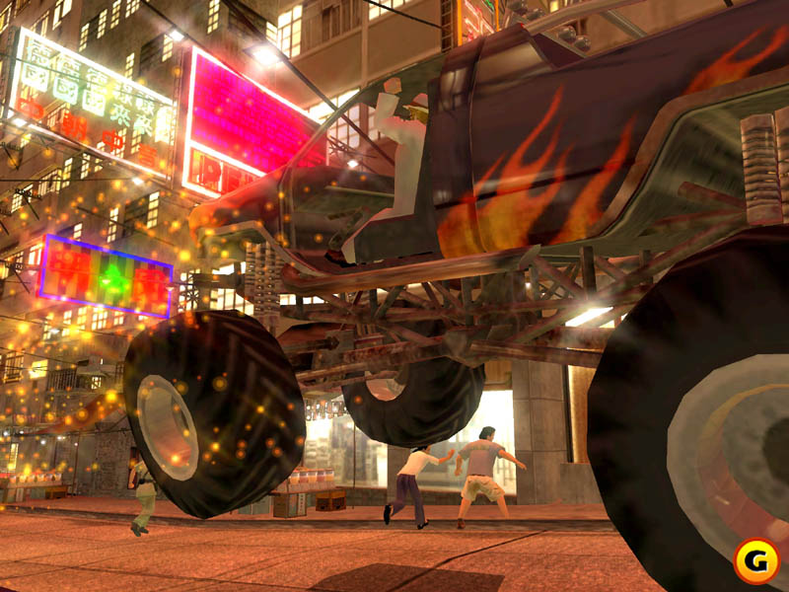

AAA Definition
What do we define AAA? For this document, it is defined as large selling games. While we’re a game based on driving, we aren’t directly competing against “racing” games. For that reason, we are using benchmarks of the above games for look, feel, gameplay structure and appeal. The core AAA must be applied to the authentic translation the Simpsons into a polished, interactive 3D environment. If it looks, plays, sounds, feels, and plays like the Simpsons, we’ve achieved one of our goals.

Timeliness of release
Our game could be described as “timeless” as the Simpsons Phenomenon shows no signs of slowing down, or becoming stale. 13 years + of reference material, and a non-linear storyline based on the Simpsons family is “in style” at any time. The main points to consider are Fiscal timeliness and Seasonal Timeliness.

Authenticity of Characters
The is absolutely key. We set a standard for character quality with the release of Road Rage. With other FOX titles using our models as not only a guideline, but in some cases, actually using our models in game. We will continue to use the authentic voice talent for our characters, base our style and colour scheme on the accurate Simpsons Templates, and our stories will reflect what would actually happen in Springfield with little artistic license.

Licensed Gameplay
As you look at the series of Simpsons games, you either hit it, or you don’t. The Simpsons Wrestling title was a poorly reviewed game, and although sales (especially in the UK) were initially strong, the damage it did to the “license and relationship with both Gracie Films and Matt Groening” is something to keep in mind. Anybody can slap a license on a title, but in our case – the publisher / copyright owner won’t allow us to do that, and hold us to an exceptionally high level of quality. Simpsons fans will snap up just about any title, but it’s our goal to snap up the casual or non-Simpsons fan in addition to the hard-core fans. By focusing on the characters, the look, and the authenticity, as long as we have proven gameplay concepts, this will be a hit title.

The Strength of the License
This is the Simpsons. It simply doesn’t get any better than that. Millions of fans, 13 years of shows, countless products and merchandise, even the fact that people say “Doh!” in real life situations is testament to the popularity and endurance of this license. And the fact that it’s an animated show, certain liberties can be taken with reality – a concept that is a perfect match for a video game.

Summary

Product Quality Goals

Fun to play – Funny to play.

True to the license.
- Is the game representative of the actual show? People should believe that his is a Simpsons game through and through. All the humour and sight gags will be present. If the game isn’t making both the hardcore Simpsons fan, and the casual gamer laugh, we haven’t done our job.

Game play mechanics and response
- Easy to pick up and play. Can the user pick up and play the game immediately without reading manuals, or following a long learning curve? It will be direct and to the point, the user should find it easy to drive through the world, yet challenging to complete the mission, and take in all the humour and sight gags. At the end of every game, the user should feel rewarded – and still be smiling about something that just happened in the game.
- Predictable physics – the user should be able to predict what kinds of objects can be crashed into / run over, and the reaction that will occur afterwards. There will be no sudden stopping when hitting a curb or a shrub, but a wall will stop you cold.
- Tight Control – This is an arcade game. This isn’t a sim, this isn’t a touchy control mechanism. You’ll be able to rip around the city from your first game. The user will be able to both make a turn, or the same turn with a 4-wheel slide. It’s all about early reward, and often!
- Mission complexity – The missions will start off small and simple, and as you progress, the intensity will increase accordingly. A simple “catch” mission can eventually end up as a “catch, corner, steal object, avoid recapture and final destination rewards”. It should be enough to allow the user to progress at a meaningful pace in the beginning, and ramping up accordingly.

The environment
- Interactive Landmarks / and interiors – The world in which the user drives will consist of 2 different levels of interaction. The cars and pedestrians you deal with, and the landmarks / internal building environments / static objects. It should be obvious which items you can and can’t interact with. There should also be some surprises along the way with collapsing walls, etc to provide the user with some unexpected but welcome rewards.

The Eye / Ear Candy.

Sound
- Simpsons – Authentic sound. This is absolutely key. A wide array of comments with hilarious interactions must be present in all areas of the game. The Simpsons is 50% look, and 50% dialogue. We need to nail both. The dialogue must be funny, quick, seamless, and not repetitive (within reason)

“Appropriate – yet hilarious sight gags”
- Authentic in game references to the show. –The user will be bombarded with “from the show references” throughout the game. All the familiar, and obscure references from The Simpsons will be recognizable to the casual fan, but will win appreciation from the die-hard fans as well.

Taking the Simpsons to the next level of quality (in video games)
- A living, breathing, Springfield – This new version of Road Rage will include pedestrian traffic with AI, moving objects, “a general feeling of things going on in the world” not just on the streets.
- Higher quality and resolution art. – All the art is overhauled to take full advantage of the next-gen consoles. This will be done without compromising the authenticity of the license.
- Frame Rate - 60 fps.
- Fast load times. The levels will load quickly, and the user won’t ever have to return to the front end, other than to change modes of play. Everything you need to do in game, is in game.

Checklist for IP – ingame.

Characters
- Authentic Roster of Player Characters, and NPC’s. – The characters should look and act as they do in the show. The animations will be matched to the style of animation in the show, and the voices – authentic, and context appropriate. When Barney burps, he’ll burp in the game visually as well.
- Rewarding Cameo Appearances – Drop-ins from movie and music land are a goal for this game. This is dependant of Fox’s delivery of such, but cameos will bring a whole new element to the game. There should be a lot of “oh wow! I can’t believe they have ________ in the game.

Environments
- Authentic and varied Simpsons Locales – Our game will have recognizable areas in the game, along with well-known landmarks. From Moes to the Kwik-E Mart, to the Escalator to Nowhere, we’ll connect to the Simpsons fan with all of the in-show references. Each environment will be tailored to the missions. Downtown, Evergreen Terrace, Squidport, etc.

Unlockables and Rewards.

Unlockables
- Unlockables – As is with most games, unlockables are the key here. Cars, Locations, characters, and bonus features like “star characters or holiday levels”. Our gameplay system will allow regular unlocking of new things as the user progresses, but will keep a few “big ticket” items for the toughest missions.

Product Quality Checklist
GOAL | FEATURE | KEY SUCCESS FACTORS | BENCHMARK | CHECKPOINTS | DATE | DONE
Is it true to the Simpsons License? | Game Delivery and presentation | Hilarious references to the show, characters, and situations that could likely happen to the Simpsons. If the user isn’t laughing the first time they play it, it’s not good enough. | The Actual Show  Do the things that happen in the game, happen in the show? And is it hilarious?
The game is easy to pick up and play. | Control and feel | Our game is easy to pick up and play without needing to read a manual. The basics will allow you to have a great time playing the game with a reasonable learning curve | Simpsons Road Rage, Gran Turismo series
Easy to learn but hard to master all the moves | Control and Feel | Our game, although easy to play, will allow for some advanced manoeuvring and “creative license – style” moves. Again, it must focus on the fun. | It’s as easy to play as Crazy Taxi. You can do the basics. But the 4 wheel drift, etc are hard to do. Is it as fun as wipeout XL?
the user should feel rewarded | Control and game mechanism | The user will feel like they’re getting a complete Simpsons experience from the first time they play. There will be many things to see and do from your first crack at the game. If our user feels the things they want to see are out of reach, we’ve failed. | Seeing cool things are every step of the way.  Hydro Thunder, Ridge Racer 4, twisted metal. There’s tons of things going on here.
Predictable physics | Control and game mechanism | The user, after some initial gameplay will be able to know exactly what they can and can’t do. They should know how far they can jump, if they can “make that upcoming turn or not, but still have some “fun unpredictable results” from time to time. | Crazy Taxi
Tight Control | Control and game mechanism | The game is ARCADE STYLE and not a sim. It should feel like an arcade racer, and not a racing sim. The jumps should be crazy, but still allow total control once on the ground | Crazy Taxi, SF RUSH 2049.  NOT WRECKLESS – THIS IS AN EXAMPLE OF HOW NOT TO ACHIEVE THIS
Mission complexity | Design | The game should start out easily with achievable results early on. The user should feel like they can complete missions at a good pace – ramping up exponentially in complexity. Not too hard or too easy early on. | Spy Hunter, Wreckless, GTA3
Interactive Landmarks / and interiors | Art and Design | The landmarks should be interactive. You must be able to drive up and off the escalator to nowhere, Krusty’s drive through should work at some level, DUFF brewery should be a working brewery, animations and movement will be seen throughout. | Actual Show
Authentic in game references to the show. | Presentation | All trademark buildings are accurate and quickly recognizable. The user will see landmarks and immediately be able to refer to the episode or reference they are based on. If they user isn’t thinking “I remember that, I can’t believe they have THAT in there” we haven’t done our job | Actual Show
Simpsons – Authentic sound | Audio | The Authentic voices and character traits will be present in the game. The user will recognize not only the accuracy of the voices, but the context and content of the things they say. AND they will be funny. | Actual Show
A living, breathing, Springfield | Presentation / graphics | Our game will feel alive. There will be moving objects, cars, building elements, pedestrian and wheeled traffic, clouds, etc throughout the game. If you’re not moving in the game, the world will continue to move without you | Actual Show / GTA3
Higher quality and resolution art. | Presentation / Graphics | The game will look and feel sharper and more vibrant than the first game. Colours will be richer and deeper, horizons will blend hues, shadows and lighting will be incorporated. Night-time and dusk effects will be introduced. Characters will embody facial expressions, lip synching and head turning | Ridge Racer 4 has nice effects like this.
Frame Rate | Gameplay | Our frame rate target is 60 FPS
Fast load times | Gameplay | Our game will load in less than 10 seconds. | Wreckless (fast loader!)
Authentic and varied Simpsons Locales | Environments | Our game will be accurate to the buildings, locations, and atmosphere of the original show. Moe’s will look, feel, and sound like Moes. The Quik-E-Mart will look, feel, and sound like the one from the show. The districts and landmarks will be accurate and authentic. If any of our buildings or landmarks don’t look like they were taken from the show, or are inaccurate in scale, we haven’t done our job.
Unlockables | Gameplay content / Features | Our game will have unlockable areas to play in. Our game will have unlockable vehicles / characters to play with. There must be a constant “motivating factor” for the user to play through the game. | Any typical racer that has unaccessible areas until early stages have been cleared. Bandicoot racing, Gotham, etc.
Rewarding Cameo Appearances | Characters | Our game (if characters are licensed for this purpose), will have some hilarious cameos. The kind of thing that will have people laughing out loud. They won’t believe their eyes – or the fact that we’ll have “Simpsonized” real life celebrities in the game. | Ready to Rumble II  (with Michael Jackson and Shaquille O’Neal)

